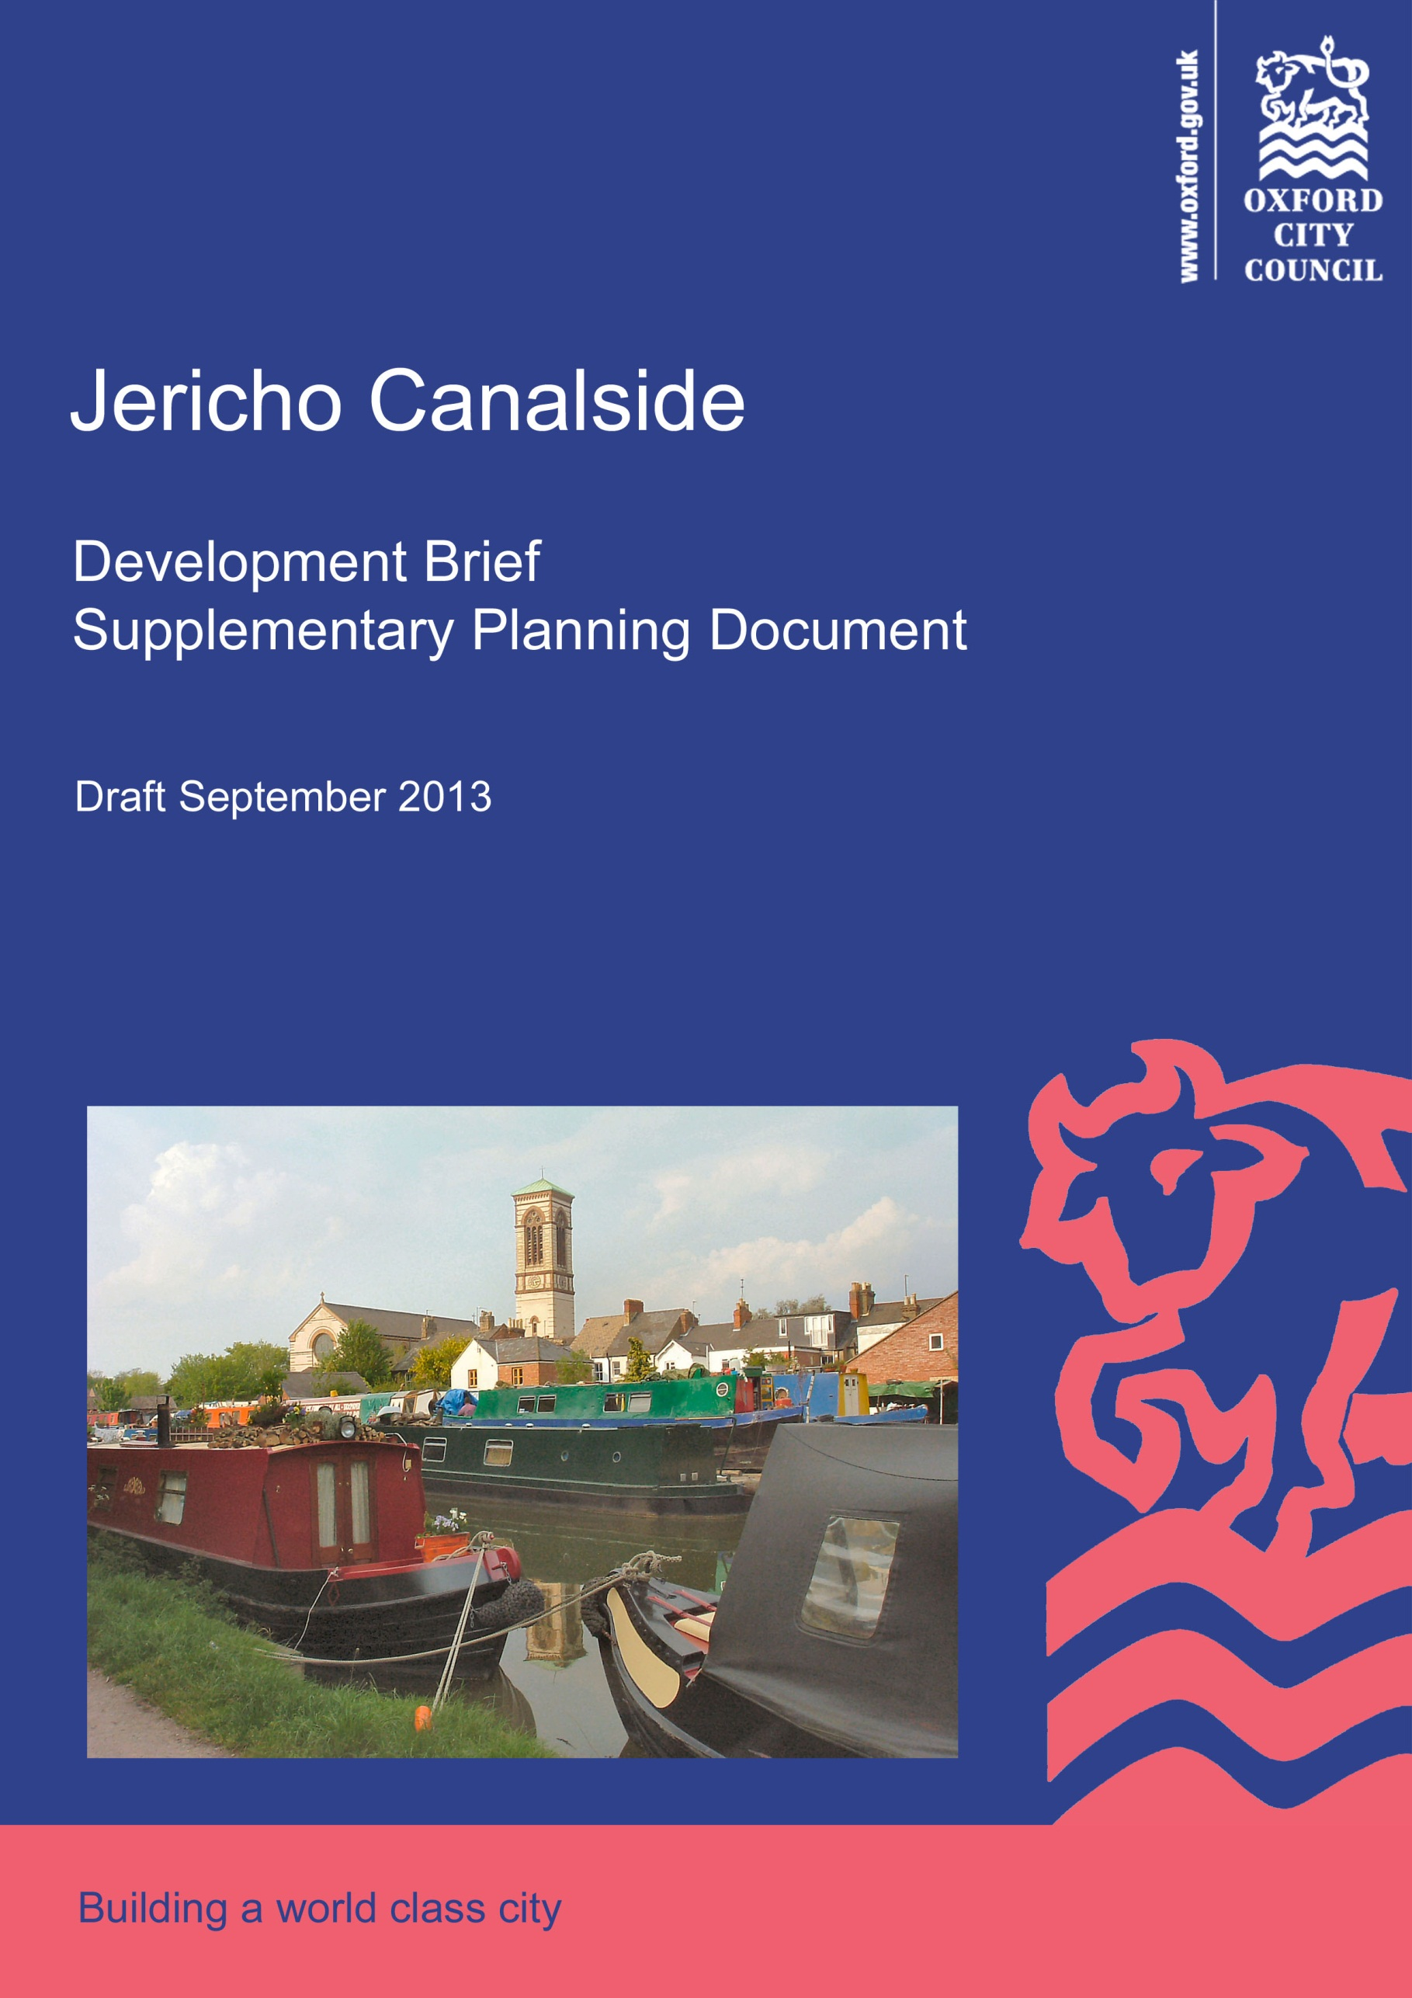
CONTENTS
1.0 Introduction 3
2.0 Objectives 4
3.0 Relevant planning policy 5
4.0 Characteristics, constraints and opportunities 10
5.0 Community aspirations 15
6.0 Development requirements 17
7.0 Design principles 28
8.0 Framework plan 33
9.0 Delivery and implementation 35
10.0 Further information 38
11.0 Appendices 39

All maps © Crown Copyright and database right 2013. Ordnance Survey 100019348.
Cover photo of the site courtesy of Isisbridge.

Introduction
This Development Brief supplements Policy SP7 of the Sites and Housing Plan which allocates the Jericho Canalside site for a mixed-use development. It explains the vision for the site of the City Council, evolved with the local community, and will assist developers in the submission of high quality proposals befitting of the site’s character and heritage.
This site is possibly one of the most complicated sites in Oxford in recent times due to the variety of competing uses expected and the challenge of balancing community uses with high value lucrative residential development. Oxford is one of the least affordable cities in the UK, as cited in the Centre for Cities report, but with a huge property demand for property. It is also a site which attracts alot of public interest being close to the heart of many Jericho residents and Oxford canal boaters due to its heritage and location.
The City Council and local people are eager for the site to be developed rather than stand empty as it has done for over 5 years. It is hoped that this Brief will help achieve this.
The reasons for producing this Brief are:
- to help applicants make a successful planning application;
- to be clear on the City Council’s expectations drawing upon issues and elements in relation to past applications and appeal decisions that remain relevant;
- reduce time delay to the planning process by reducing the potential for conflicts and objections;
- to evolve a vision for the site shared by the local community and the City Council;
- to be a creative exercise in finding ways to enhance and improve the places in which people live their lives in line with the National Planning Policy Framework principle.
The Brief forms part of Oxford’s Development Plan and is a material consideration in the determination of any planning application made on the site. It has been developed through both informal and formal public consultation, meetings with key local groups and input from internal and external specialists.
The Brief has also been the subject of a formal Strategic Environmental Assessment screening ensuring that the document has appropriate legal compliance.

Objectives
In line with the Town and Country Planning (Local Planning) (England) Regulations 2012 controlling the production of Supplementary Planning Documents, the Brief must not conflict with the adopted Development Plan. The Development Plan comprises the Core Strategy, the Sites and Housing Plan and the saved policies of the Oxford Local Plan 2001-2016. In addition, the Brief must not conflict with the National Planning Policy Framework.
Existing policies within the Development Plan (set out in Section 3.0) already provide some detail on the requirements of the site. Some of these policies are open to interpretation so this Brief seeks to explain how the City Council interprets the key policies that relate to the site. This detail remains within the scope of existing policy requirements. It is hoped that this will enable applicants to make a successful planning application and speed up delivery of the site.

The objectives of the Brief are to:
    - Provide detail on what is expected with regards to the essential boatyard facilities, the new community centre, the residential and the public square (Policy SP7)
    - Provide detail on how an improved crossing over the canal for cyclists and pedestrians can satisfactorily be achieved to deliver a joined up cycle and pedestrian network (Policy SP7 and CS14)

    - Identify the unique character and distinctiveness of the site and the Jericho area to provide the context from which the design of the development should draw inspiration, in particular in relation to the heights of buildings and the area surrounding the public open space (Policies SP7 and CS18)
    - Describe how the development should respect and enhance the historic environment in particular the waterfront heritage of the site, the conservation area and the Grade 1 listed St Barnabas Church (Policies SP7 and CS18)

Relevant planning policy
The key policies of the Development Plan which are particularly relevant to this site are set out below. Any planning application will be considered against all relevant policies in Oxford’s Development Plan.
Sites and Housing Plan - Policy SP7 Canalside Land, Jericho
Policy SP7 is a site allocation for this specific site. Policy SP7 stresses the importance of the character of the conservation area and the setting of the listed St Barnabas church. It draws attention to the need for a site-specific Flood Risk Assessment and the possibility of needing to fund a study to assess water supply capacity, ensuring that the development does not cause water supply problems.
Development types expected from the site’s redevelopment:
- Residential
- A sustainably-sized community centre
- Public open space/square
- Replacement appropriately sized boatyard
- An improved crossing over the canal for pedestrians and cyclists
The text preceding Policy SP7, which holds as much weight as the policy wording itself, gives some further detail about the design requirements of the development relating to the boatyard, building heights, St Barnabas Church and impact mitigation.

Sites and Housing Plan - Housing Policies
Elements from the Sites and Housing Plan Policy SP7 that should feature in the design of the development:
- The boatyard should include a wet dock, and allow craneage for narrowboats with possible supporting chandlery and associated workshop and DIY maintenance facilities  - The canal boat hire base at the north of the site should be retained  - Building heights should reflect the form and scale of surrounding development, particularly surrounding the area of public open space and should not exceed 3 storeys | - Finished design should respect the waterfront heritage of the site, the conservation area and Grade 1 Listed Building  - The wall separating the Church and the proposed new square can be demolished to open up the square and views of the Grade 1 listed building  - In order to mitigate recreational impacts on the Oxford Meadows SAC, dog and litter bins and an information board must be provided at the Walton Well Road entrance to Port Meadow

The following policies are the main policies which will be relevant to any proposal on this site. These are summaries only and the full text should be read from the Sites and Housing Plan:
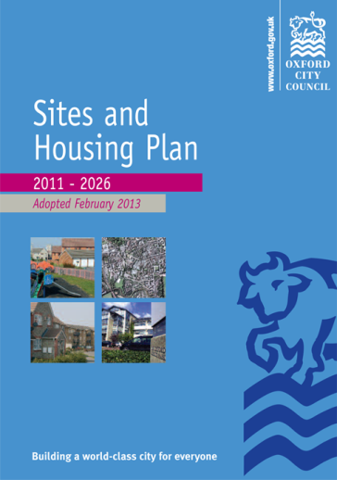
- HP2 Accessible and Adaptable Homes – all new dwellings should meet lifetime homes standards and at least 5% of all new dwellings (or at least 1 dwelling for sites below 20 units) are either fully wheelchair accessible, or easily adapted for full wheelchair use. 50% of these must be provided as open market dwellings.
- HP3 Affordable Homes from Large Housing Sites – generally a minimum 50% of dwellings on the site are provided as affordable homes. A minimum 80% of the affordable homes must be provided as social rented, with remaining affordable homes provided as intermediate housing
- HP 9 Design, Character and Context – Planning permission will only be granted for residential development that responds to the overall character of the area, including its built and natural features
- HP11 Low Carbon Homes - Planning permission will only be granted for developments of 10 or more dwellings where development proposals include at least 20% of their energy needs from on-site renewable or low carbon technologies
- HP12 Indoor Space - Planning permission will only be granted for new dwellings that provide good quality living accommodation
- HP13 Outdoor Space - Planning permission will only be granted for new dwellings that have direct and convenient access to an area of private open space
- HP14 Privacy and Daylight - Planning permission will only be granted for new residential development that provides reasonable privacy and daylight for the occupants of both existing and new homes
- HP15 Residential Cycle Parking - Planning permission will only be granted for residential development that complies with the following minimum cycle parking provision:- Houses and flats up to 2 bedrooms at least 2 spaces per dwelling; Houses and flats of 3 or more bedrooms at least 3 spaces per dwelling
- HP16 Residential Car Parking (and Appendix 8) - Planning permission will only be granted for residential development where the relevant maximum car parking standards are complied with:- Houses: 1 space per house (allocated or unallocated); Flats: Car-free, plus operational, disabled and car club parking up to 0.2 spaces per dwelling; Wheelchair dwellings: 1 space per dwelling on plot.

Oxford Core Strategy
The following policies are the main policies which will be relevant to any proposal on this site. These are summaries only and full text should be read from the Core Strategy:
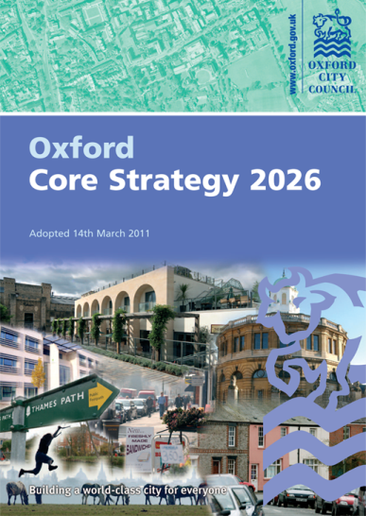
- CS9 Energy and natural resources - Proposals are expected to demonstrate how sustainable design and construction methods will be incorporated; how they optimise energy efficiency and how they utilise technologies that help achieve Zero Carbon Developments
- CS10 Waste and Recycling - All new developments will be expected to have regard to the waste management hierarchy during design, construction and final occupation
- CS11 Flooding - The development must carry out a full Flood Risk Assessment (FRA), which includes information to show how the proposed development will not increase flood risk, how it will be safe and how the necessary mitigation measures will be incorporated. All developments will be expected to incorporate sustainable drainage systems
- CS12 Biodiversity - Development will not be permitted which will result in a net loss of sites and species of ecological value. Where there is opportunity, development will be expected to enhance Oxford’s biodiversity
- CS14 Supporting city-wide movement - The City Council will work with its partners to promoting greater pedestrian and cycle priority through and to the city centre, potentially incorporating public realm and cycle parking improvements; and work towards a joined-up, city-wide cycle and pedestrian network by addressing ‘pinch-points’, barriers and missing links
- CS17 Infrastructure and Developer Contributions - Planning permission for new development will only be granted if it is supported by appropriate infrastructure at a timely stage. Developer contributions will be sought where needs arise as a result of new development
- CS18 Urban design, townscape character and the historic environment - Planning permission will only be granted for development that demonstrates high-quality urban design. Development proposals should respect and draw inspiration from Oxford’s unique historic environment (above and below ground), responding positively to the character and distinctiveness of the locality. Views of the skyline of the historic centre will be protected
- CS23 Mix of Housing - Planning permission will only be granted for residential development that delivers a balanced mix of housing. Appropriate housing mixes are set out in the Balance of Dwellings SPD
- CS24 Affordable Housing - Planning permission will only be granted for residential developments that provide generally a minimum of 50% of the proposed dwellings as affordable housing on all qualifying sites

Saved Oxford Local Plan 2001-2016 Policies
The following policies are the main policies which will be relevant to any proposal on this site. The full wording should be read from the Oxford Local Plan 2001-2016.
CP.1 | Development Proposals | TR.4 | Pedestrian and Cycle Facilities
CP.6 | Efficient Use of Land and Density | TR.5 | Pedstrian and Cycle Routes
CP.8 | Designing Development to Relate to  its Context | TR.13 | Controlled Parking Zones
CP.9 | Creating Successful New Places | NE.6 | Oxford’s Watercourses
CP.10 | Siting of Development to Meet Functional Needs | NE.14 | Water and Sewerage Infrastructure
CP.11 | Landscape Design | HE.2 | Archaeology
CP.13 | Accessibility | HE.3 | Listed Buildings and Their Setting
CP.14 | Public Art | HE.7 | Conservation Areas
CP.17 | Recycled Materials | HE.9 | High Building Area
CP.18 | Natural Resource Impact Analysis | HE.10 | View Cones of Oxford
CP.19 | Nuisance | SR.9 | Footpaths and Bridleways
CP.21 | Noise | SR.11 | Recreational Cycling
CP.22 | Contaminated Land | SR.12 | Protection of Water Based Recreation Activities
TR.1 | Transport Assessment | SR.13 | New Water-Based Recreation Activities
TR.3 | Car Parking Standards | SR.16 | Proposed New Community Facilities

Supplementary Planning Documents
The following Supplementary Planning Documents are material considerations:
- Affordable Housing and Planning Obligations SPD (Draft 2013)
- Affordable Housing SPD (2006) and Planning Obligations SPD (2007) – to be superseded upon adoption of the above
- Balance of Dwellings SPD (2008)
- Natural Resource Impact Analysis (2006)
- Parking Standards, Transport Assessment and Travel Plans Supplementary Planning Document (2007)
Technical Advice Notes
The following Technical Advice Notes will assist applicants in complying with policies
- Technical Advice Note 1: Accessible Homes (2013)
- Technical Advice Note 2: Energy Statement (forthcoming)
- Technical Advice Note 3: Waste Storage (forthcoming)
Canalside Land Development Guidelines 2001
Development Guidelines for this site were adopted in the form of Supplementary Planning Guidance in 2001. Whilst these guidelines were written under the previous Local Plan 1999-2001, many of the design principles are still very relevant as policies relating to the site have not changed significantly since then. The Canalside Land Development Guidelines (2001) is superseded upon adoption of this Brief.
National Planning Policy Framework (NPPF)
The Sites and Housing Plan includes Policy MP1 which reflects the National Planning Policy Framework’s presumption in favour of sustainable development. The NPPF contains a set of core land-use planning principles which should underpin decision-making. The elements of these core principles that are particularly relevant to this Brief relate to good quality design and the conservation and enhancement of the historic environment.
The NPPF states that it is important to plan positively for the achievement of high quality and inclusive design for all development, including individual buildings, public and private spaces and wider area development schemes. Development should add to the overall quality of the area; establish a strong sense of place creating attractive and comfortable places to live, work and visit; optimise the potential of the site to accommodate development; respond to local character and history, and reflect the identity of local surroundings and materials, while not preventing or discouraging appropriate innovation; create safe and accessible environments; and are visually attractive as a result of good architecture and appropriate landscaping.
In relation to the historic environment NPPF aspires for positive strategies for the conservation and enjoyment of the historic environment that will sustain and enhance the significance of heritage assets; recognise the wider social, cultural, economic and environmental benefits that conservation of the historic environment can bring; make a positive contribution to local character and distinctiveness; and take opportunities to draw on the contribution made by the historic environment to the character of a place.

Characteristics, constraints and opportunities
Site description
This 0.49 hectare brownfield site is within the historic suburb of Jericho, Oxford. It is bounded to the west by the Oxford Canal and surrounded on all other sides by residential development, including student accommodation to the immediate south. The Grade 1 listed St. Barnabas Church sits against the eastern boundary to the site, in the midst of the surrounding development and forms an important backdrop to the site. It is a former boatyard and workshop site and has been vacant and derelict since 2006. The northern part of the site is used by College Cruisers as a boat hire facility and informal parking while garages and open space occupy the land in Dawson Place.
The site is a great asset to the local community. The aspirations of the community are set out in more detail in the next section. By far the greatest opportunity for the site is to maximise its position on the canal and to create a unique focal point for the Jericho community whilst also delivering housing.
Heritage
The Canalside
The canal and wharves have been included within the Jericho Conservation Area in recognition of their contribution to the special historic and architectural interest of the area and the desirability of preserving or enhancing its character and appearance. The special interest of the area has been defined within the Jericho Conservation Area Study, which also defines features of the canalside and surrounding residential streets that are considered to make a positive contribution to Jericho’s character and appearance.
The Oxford Canal has a special historic interest as the first man-made waterway to provide an inland route between the coalfields and manufactories of Birmingham and South Staffordshire with the metropolitan market of London. The canal had a significant impact on the development of the country’s industry and trade, whilst Oxford occupied an important point at the junction between the canal and the River Thames. Small buildings of industrial character within the wharves provide some evidence of the transhipment activity that took place, and later use for boat maintenance. The wharves at Jericho influenced the character of the area’s later development by promoting the development of resource hungry industry such as iron working and publishing, with the attendant growth of workers’ housing. This lead to the creation of an industrial suburb of modest, low-scale workers’ housing on the edge of the city.
Latterly the wharves have provided a linking space between the land dwelling community of Jericho and the developing waterborne community of the canal, providing public access to areas that allow an appreciation of the canal’s influence on Jericho’s development. Through the development of use of the wharves as a boatyard, the area has developed communal value for boat-dwellers, in particular as a shared space that has helped to develop community cohesion and interaction. The canal has developed a ’wild’ rural character, in many ways indistinguishable from backwaters of the river Thames. This is partly a result of a planting of native species trees alongside the towpath, which have developed a naturalised under-storey. These provide a value to the amenity of the site by screening the noise and views of the railway to the west and the appearance of new developments at Rewley Road and Roger Dudman Way.
St Barnabas Church
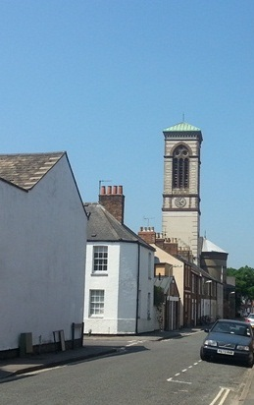
St Barnabas Church is a Grade I listed building in recognition of its exceptional architectural and historic interest. It represents a highly unusual example of Italianate Romanesque architecture from the great period of Gothic Church building in the 1860s and includes the innovative, (for the time), use of concrete. The church was built with funding from Thomas Combe, superintendent of the Clarendon Press (Oxford University Press) and designed by the architect Arthur Blomfield. Combe was a prominent patron of the pre-Raphaelite artists and the drama of the church seen in the setting of the canal and its unusual architectural character may be seen as a product of his artistic interest.
The church is a prominent feature in views along Canal Street and Cardigan Street, where the pale cream elevations contrast with the red of brickwork. The building, including its tower and campanile, rise high above surrounding terraces. The church is also prominent in views from the canal, partly as a result of its position next to the canal wharves, which have generally remained open between the church and waterfront throughout its history, with development limited to single-storey sheds. Historically the church was also approached by doors from the canalside.
St Barnabas Church from Canal Street
Jericho’s Historic Streets
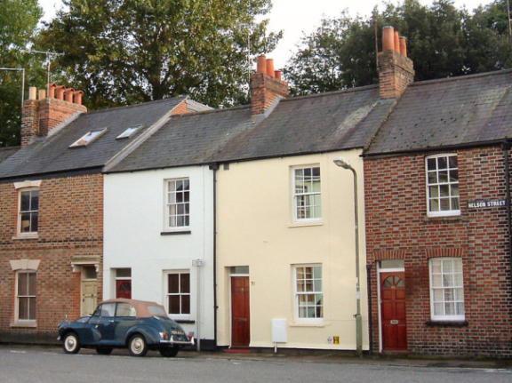
The surrounding residential streets of Jericho have a distinctive architectural character resulting from the high density development of workers’ cottages with a, generally, uniform two-storey scale, continuous rooflines with chimneys and regular pattern of window and door openings, historically typified by timber-framed sash windows and panelled doors. These are distinguished by a great variety of architectural decoration notably through use of patterned brickwork and window detailing and forms, creating an ever changing frontage within streets.
A typical street in Jericho (photo courtesy of Isisbridge)
The streets in this area are tightly enclosed, intimate spaces, in which houses stand directly at the rear of the pavement, creating long, channelled views. Buildings occasionally rise to three storeys, although these are rare and more than two-adjacent properties of this scale are exceptional. Street corners are normally typified by two-storey returned frontages. The scale and uniformity of development reflects the historic social standing of Jericho’s residents’ although the wealth of architectural detailing reflects the strong sense of individualism within this community in the 19th century.
Archaeology
A substantial amount of made ground exists across the site comprised of medieval rubbish dumping as the site was not under occupation before the 19th century. In archaeological terms the site possesses only low potential for containing remains of local or regional significance. For the prehistoric period low general activity is shown for the area whilst for the Roman, Saxon and Medieval periods the potential for remains is also low. There is some possibility of remains from the post-medieval period in the form of remains of buildings that originally stood as part of the canal wharf. There is however a high potential for palaeo-environmental remains. Conditions requiring an archaeological field evaluation, method statement for the design of foundations and other ground works, and archaeological recording action are therefore likely to be imposed on any permission granted.
Flooding
The majority of the site is within Flood Zone 3a with part of the northern area within Flood Zone 3b. During the production of the Sites and Housing Plan, the Inspector was satisfied with the evidence provided by in respect of the Sequential and Exceptions Tests and subsequently allocated the site for development. Policy SP7 requires a site-specific flood risk assessment (FRA) and that development should incorporate any necessary mitigation measures.
As evidence base for the Sites and Housing Plan, a Level 2 Strategic Flood Risk Assessment (L2SFRA) was completed in respect of this site which concluded that Part C of the flood risk exception test would be passed based on the current information but that further technical assessment is required. Applicants will be expected to carry out the technical assessment to confirm whether Part C of the Exception Test could be passed.
The Environment Agency are currently undertaking a detailed hydraulic modelling (1D/2D modelling) exercise of the major Oxford watercourses. This work is expected to be completed in Summer 2013. It is not clear at this stage whether there will be any change to the Flood Zone classification at this location. The outputs of this model could be used to assess flood risk which may allow the recommendations of the L2SFRA to be met.
Surface water runoff should be managed on the site through the use of Sustainable Urban Drainage Systems, attenuating runoff to greenfield runoff rates if possible but at least 30% less than existing runoff in accordance with recommendations for Critical Drainage Areas.

Biodiversity
The biodiversity most likely to be affected by the development is bat roosts which depends on the construction type and the maintenance level of the buildings. Applicants will be expected to undertake building surveys for bat suitability and further surveys as necessary. In terms of bird life it is recommended that buildings are either demolished outside the nesting season, or birds discouraged from using the site by blocking access to them and checked again prior to demolition.
Core Strategy Policy CS12 states that development will be expected to enhance Oxford’s biodiversity. The boatyard has potential to see biodiversity enhancement for three groups of organisms of biodiversity concern that use the canal corridor here:
    - Bats - through suitable trees and roosting structures in buildings
    - Birds - through landscaping and bird boxes on buildings
    - Water voles - through the creation of some vegetation area at canal water level along the edge
Applicants will be expected to assess whether any of the biodiversity enhancement features can be incorporated into the development. Suitable features will be secured by condition or planning obligation.
Trees
Development of the site might require the removal of the mature false acacia and silver birch trees that stand on a small area of public open space, Dawson Place, at the corner of Dawson Street and Canal Street. They are good quality and have a significant safe useful life expectancy in excess of 40 years. The false acacia in particular is a prominent feature of public views along Canal Street and is important to the setting of St Barnabas Church, while both trees are visible in views from the canal providing screening from the urban area behind helping to protect the rural character of the canal. The removal of these trees will have an adverse effect on the appearance and character of the area in public views and will be detrimental to the setting of the church. However, on balance, it is likely that the public benefits provided by the development outweigh these impacts.
The other trees within the site are self-seeded, the most significant being a small group of sycamore and ash trees that stand in the south-west corner next to the canal and boundary with Worcester College. Although these trees are reasonably large, their amenity value is low. The presence of other large trees growing along the boundary within the ground of Worcester College will ensure that their removal will not have a significant visual impact and is therefore acceptable.
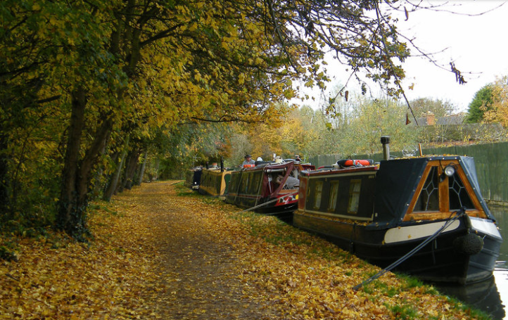
Outside of the site, the canal corridor is of ecological significance not only to Jericho but also to Oxford as a whole. It represents one of the green corridors that brings the countryside into the urban area and contributes to Oxford’s unique spatial form and character. It is a riparian habitat characterised by indigenous trees including field maple, wild cherry, alder, crack willow, hawthorn, ash, elder and hazel, all growing between the canal and Castle Mill Stream. The trees have an important group value, contributing to the special ‘green amphitheatre’ setting of Jericho, which is described in the Jericho Conservation Area Study. This combined with a non-interventionist approach to vegetation management gives the canal corridor it ‘wild’ rural feel. Decisions about the design and location of any new bridge linking the site with the canal towpath will necessarily be a balance between various competing interests, but great weight should be given to the significance of the trees along the canal and the need to minimise harmful effects on these trees as far as possible.
The tree lined towpath opposite the site (photo courtesy of
Isisbridge)
Development might also affect trees that stand in the garden of adjacent properties; for example the mature hawthorn tree and 2 cypress trees which stand within the rear gardens of properties in Combe Road. While none of these trees is particularly important and their removal will not have a significant impact in public views, the management of these trees will be outside of the direct control of any developer. Unless the owners of these trees agree to their removal it will be necessary for the layout of the development to avoid harming these trees.
The development is expected to provide new opportunities to plant new trees for the benefit of amenity in the area. It is likely to be necessary to plant new trees to mitigate the visual impacts if trees are to be removed from Dawson Place for example.
Contaminated land
In view of the site’s previous boatyard and industrial uses the possibility exists of elevated levels of methane and hydrocarbon contamination which would require full remediation before construction could begin, possibly including some extraction of material.

Community aspirations
This site is very important to the local community being at the heart of Jericho and having a rich heritage. They consider that it has the potential to become a vibrant hub of activity for local people and visitors. They recognise that it is the only development opportunity in Jericho which could deliver a new community centre and a replacement boatyard and they would like to ensure that the site is developed with the right facilities.
The community themselves have undertaken considerable consultation, background work and fundraising with an aim of acquiring and developing the site in the interests of the community. The Jericho Wharf Trust (JWT) is a community organisation set up for this purpose and has been co-ordinating activities. JWT comprises four partner organisations:
- Jericho Community Boatyard (JCBY);
- Jericho Community Association (JCA);
- Jericho Living Heritage Trust (JLHT);
- St Barnabas Church Parochial Church Council.
The City Council have been keen to understand the aspirations of the community and, in the spirit of the National Planning Policy Framework and the localism agenda, felt it very important to work closely with the community on this Brief. This is an excellent opportunity for local people to have a hand in the design of the development. To not involve and listen to the community would be a wasted opportunity and contrary to current government guidance.
Drop-in consultation event (July 2013) and other surveys
Consultation enables the City Council to obtain views from a sample of the local community. The views of the community are one aspect which feeds into decision making. Other aspects include the existing planning policies, political views and the need to deliver sustainable and viable development. Each of these aspects must be balanced against each other to try and deliver a development or document that satisfies these matters to an optimum degree.
Inevitably not every suggestion made through the consultation will be taken forward but the City Council aspires to act upon any clear patterns or consensus that emerges from consultation responses.
There was already a considerable amount of information available to help understand how the community would like to see the site developed, however, it remained important for the City Council to undertake its own independent consultation event. This consisted of a drop-in event in the current Jericho Community Centre. Flyers were produced by the City Council and distributed by the JCA to over 1,000 homes in Jericho.
The Interim Public Consultation Statement contains more detail on the matters raised. Some matters showed a clear consensus but some showed a divided opinion which is also significant. Below are the matters from the consultation that have directly influenced the Brief:
- Whilst there were many different opinions on how much of each use would be appropriate, the most popular opinion was that the mix of uses (residential, boatyard, community centre and public square) should be broadly equal. The City Council would agree that this approach would deliver a truly mixed development and should be the starting point for design considerations.
- In terms of the location of uses, there was clear consensus that the boatyard would be best placed at the north of the site next to College Cruisers and that the public square should be in front of the church. There was some agreement that there should be at least some housing on the southern part of the site. The City Council would agree with this approach.
- There was divided opinion as to the preferred location of the community centre with suggestions evenly split between the Dawson Place end and the southern end of the site. The Jericho Wharf Trust feel strongly about it being located south of the square. This is one reason for this being its preferred location within the SPD.
- There was generally agreement that the community centre should be larger than the current centre and multi-functional with small and large rooms capable of accommodating a wide range of activities. This opinion was also clear from other non-Council consultations referred to in Appendix 2 with which the City Council would agree.
- There was divided opinion as to the preferred location for a new bridge with suggestions split evenly between the southern end of the site and a more central location leading onto the square. Similarly, there was no clear agreement as to the most appropriate type and style of bridge. For this reason, and because of the many factors to consider with regards to the bridge as detailed in Section 6.0, the City Council will remain open minded about the most appropriate location for the bridge.
- There was overwhelming support for a footpath along the canal frontage. This re-affirmed the City Council’s view that space should be retained along the canal frontage to the south of the site leading from Great Clarendon Street to the new square not only for public access but for canal maintenance and boat access.
- There was general agreement that 3 storeys is the maximum appropriate height of buildings (in line with Policy SP7) but also that 2 storeys will be more appropriate in some locations depending on any impact upon neighbouring buildings. For this reason this Brief adds some guidance on this matter.
- There was general agreement that there should be little or no car parking on the site. This re-affirmed the City Council view that this would be a suitable location for low-car or car-free development and guidance has been added on this matter.
Appendix 2 refers to other relevant non-City Council surveys and consultations.

Development requirements
Boatyard
The site is adjacent to the Oxford Canal which runs from Coventry to Oxford. The closure in 2007 of the Castle Mill boatyard on this site left a deficiency in boatyard provision on this part of the canal where there had been boat building and repair since at least 1842. Policy SP7 expects a boatyard to be re-provided on the site to replace this deficiency and to meet local need. It should include a wet dock, craneage, chandlery, workshop and DIY facilities. Adequate boatyard facilities are vital in sustaining the community who choose to make their home on a narrowboats. They must be able to conveniently carry out the necessary servicing and repairs to that home as would be expected by people living in brick built houses. This stretch of the Oxford canal has an estimated annual boat count of 4,547.
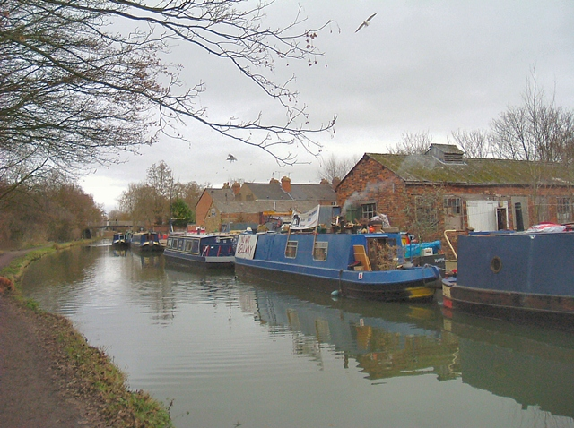
The nearest boatyard on the canal with a reasonably full level of facilities and services was Alchemy Boats near Yarnton, however, the future of the boatyard is uncertain as it is currently closed and it has no security of tenure. It had no DIY facilities or hardstanding so it lacked some of the essential facilities. The new owner has applied for planning permission to develop the site for a marina to include a boatyard but this application has been withdrawn. It is unclear whether development on the site would be permitted as it is in the Green Belt and within Cherwell District Council’s District Authority area. The next nearest boatyard with a full level of facilities and services is Heyford Wharf 14 miles away but when the River Cherwell is in spate, (in flood or fast flowing due to heavy rain), it is not always possible for boats to get beyond Thrupp to access it. Some facilities are available at Osney Marina but similarly, these are on the river and not the canal.
The former boatyard on the site (photo courtesy of Isisbridge)
College Cruisers adjacent to the Jericho site offer a range of services including mechanical, carpentry, welding and gas services; pump outs; rubbish dumps; diesel; chandlery items within 24 hours; boat safety tests and landlord certificates. College Cruisers do not have a permanent method for lifting boats but hire a crane when required. They do not have a dry dock.
At the present time only College Cruisers offer a level of services in the Oxford area on the canal which can be accessed at all times although it does not provide all of the essential services. It is also possible in the future that new boatyard facilities will be provided at Yarnton but this is not guaranteed. The level of boatyard facilities required at Jericho should therefore reflect the potential for the situation to change in the future. This is particularly important if a planning application is submitted some years after adoption of this SPD.
Essential boatyard facilities are:
- A covered wet/dry dock with hard standing space and a mechanism for lifting boats out of the water - Residential boats each need to undertake repairs every four years taking approximately two weeks every time for the required blacking and repairs. The appropriate number of dry berths will depend on the number of boats in the Oxford area. If there is demand, an extra dry berth may be required for long term projects such as when a boat is burnt out. Each berth would need access to electricity and a tap. Hard standing space is required for circulation around the boats that are being worked on out of the water (1 metre around a boat).

- Indoor DIY workshop space and store room - This is where repairs on engines and fittings can be made and where paints, cleaning equipment and tools can be stored. In order for the boatyard to be genuinely DIY there will need to be workshop provision to enable boaters to carry out work off the boat. This will need to include space for carrying out woodwork, metal work and work on engines that need lifting out of the boat

- Chandlery and small office - a small shop where boaters can obtain essentials for maintaining their boats which provides an essential source of income for most boatyards. The office would support the running of the chandlery and the boatyard

- Service docks - The site should accommodate service points for boats alongside the wharf for work that doesn’t require boats being lifted from the water. Each one would require an electricity point and at least one metre of wharf front to be available for boaters to get on and off their boats and carry out DIY repairs. Boaters should be able to fill up with water, use an Elsan point, fill up with diesel, gas, coal, wood and drop off rubbish

- Toilet and possible shower/laundrette facilities - For boat owners whose boats are out of the water and are unable to use their own bathrooms. Few boat owners have washing machines.
The appropriate level of these essential boatyard facilities, which would determine the appropriate size of the boatyard, would depend on the following factors:
    - The number of boats within the Oxford area in which the boatyard would serve including any projected growth in boat ownership. It would be appropriate to consider the “Oxford area” as Oxford plus the canal north to the River Cherwell up to and including Thrupp. This is the area in which narrowboats would be restricted to in times of flood.
    - The quality and provision of alternative boatyard services within the Oxford area and whether they are in an equally accessible and suitable location
    - The likely noise impact and disturbance from the boatyard on nearby properties
    - The commercial viability of a boatyard bearing in mind its likely level of trade
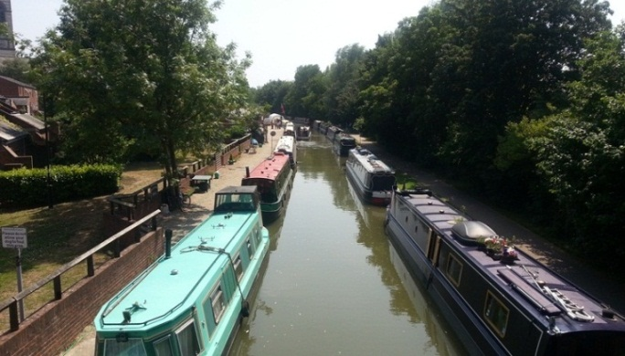
The appeal Inspectors into the 2003 and 2007 applications, raised concerns that the Jericho site would be unsuitable for intensive commercial operation but also that the distance of the Alchemy Boatyard weighed against its accessibility and suitability. A replacement boatyard in Jericho has the potential to create noise disturbance for neighbouring properties. It should be demonstrated that the boatyard will not cause unacceptable disturbance to properties through its design, materials and operating hours (which may be controlled by condition)
The Oxford Canal in Jericho
Applicants will be expected to provide evidence to support the level of boatyard facilities proposed. Opportunities for the community centre and boatyard to share some facilities would be considered favourably.
Position
The most appropriate position for a boatyard would be at the northern end of the site as this is the area most liable to flood. A boatyard is classed as a ‘water compatible use’ so this approach would help ensure that the less vulnerable and more vulnerable uses (community centre and residential) can be focussed on the area least liable to flooding. This should be confirmed by a site specific flood risk assessment.
Community consultation also expressed a preference for the boatyard to be positioned at the northern end, particularly as there may also be potential for shared uses with College Cruisers.
Winding hole
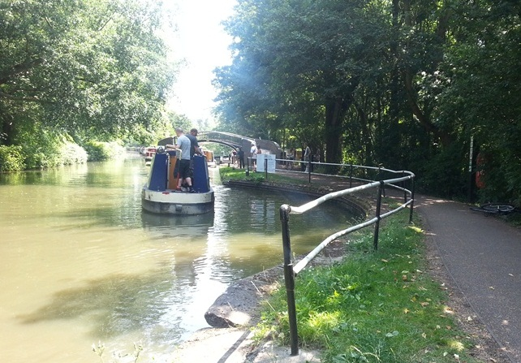
The canal terminates about 500 metres south of the site meaning that narrowboats need somewhere to wind (turn around) in order to travel north. The Hythe Bridge Arm winding hole is located just south of the site but this only allows boats up to 52 feet (16 metres) in length to wind. The only option for the larger boats up to 72 feet (22 metres) is to travel south through Isis Lock and either wind in Castle Mill stream or travel up the Thames to Duke’s Cut and re-join the canal north of Oxford. However, when the river is in spate it is not possible for boats to enter the Thames or Castle Mill Stream. This means that during winter, when it is common for the rivers to be in spate, narrowboats are trapped at the southern end of the Oxford Canal. To enable all narrowboats to wind, the site is expected to incorporate a winding hole that accommodates boats up to 72 feet.
The Hythe Bridge Arm winding hole
Community Centre
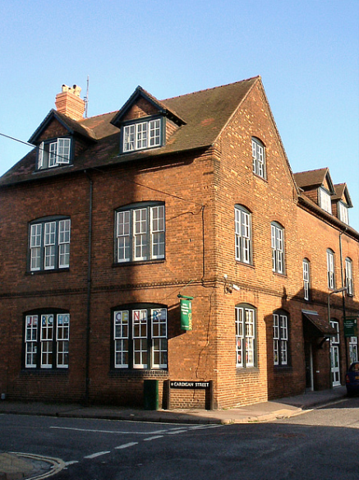
The existing community centre in Canal Street occupies a converted three storey Victorian building. It has been identified as being inappropriate for this use in view, in particular, of the absence of a large hall, and the difficulty of accessing upper floors where no lift is available and hence lack of compliance with the Disability and Discrimination Act (DDA) 2004 and lack of outdoor play space for a pre-school play scheme. To bring the building up to DDA requirements would not be viable and would be counter-productive in terms of the resulting loss of space. The current community centre is constrained in terms of internal layout and lack of external space. The Jericho Canalside site has been identified as a site for a replacement Community Centre in the Sites and Housing Plan Policy SP7 and in the superseded Local Plan Policy DS.13.
The existing Jericho Community Centre (photo courtesy of Isisbridge)
The Jericho Community Association (JCA) undertook a considerable amount of work assessing what would be needed in a new community centre and submitted an outline planning application (09/01203/OUT) on part of the site which was approved in 2010. This permission has lapsed although the background work undertaken by the JCA with the community is still of relevance. The uses considered necessary by the JCA at that time were a new multi-use community hall, café and kitchen/servery, pre-school facility with external area, changing and shower rooms, multi-functional small studio hall, meeting/education rooms, studios, offices and lifts to allow full DDA access. The JCA assessed a need for about 1,400m² Gross External Area (GEA).
The community centre is expected to be ‘sustainably-sized’. This means that it must be large enough to accommodate the likely demand from the community but not so large that it would not be fully and regularly utilised and not so small that it would be uneconomic to run. In relation to the appeal into the 2003 application, the Inspector concluded that the area of the site (net developable area of 260m² footprint) being offered by that appellant for a new community centre () was inadequate. With the Inspector also concluding that at least two-storeys would be required to accommodate a hall, a floorspace of at least twice 260m² (520m²) could be interpreted as being inadequate in the Inspector’s view. The Inspector stated that the community centre site would need to be “considerably larger” than what was proposed.
The SPD does not set a precise floorspace requirement but taking a balance between the expressed need of the Jericho Community Association and the guidance by the 2003 Planning Inspector, GEA in the region of 1,000m² GEA would be an appropriate guideline. The new community centre is expected to be DDA compliant.
Applicants will be expected to demonstrate how they have assessed the requirements of the community centre in liaison with the City Council’s Communities and Neighbourhoods team and the Jericho Community Association. The onus should be on any developer to demonstrate that the community centre will be viable in the long term. Evidence should be submitted with a planning application to support the community facilities proposed. Opportunities for the community centre and boatyard to share some facilities would be considered favourably.
The new development on the Canalside site will result in the existing community centre becoming available for redevelopment. Under Core Strategy Policy CS20, any proposal that results in the loss of existing community facilities will be expected to make provision for new community facilities. External funding will be expected to help deliver the new community centre. In addition, £100,000 is currently available from existing s106 funds as contribution towards the new community centre (although there is a time limit on its spending), plus the City Council can contribute £100,000 towards its development.
Position
It is preferable for the community centre to occupy a position directly onto the new public square. This creates active frontages, animation of the public space and a presence around the square. It allows the community uses to spill out onto the square and increases its vibrancy. To ensure maximum integration with the square, a position to the south of the square on its longest length would be most appropriate and together with the church and the canal frontage helps frame the square and promotes a shared public space and interaction. Spreading the active/public uses (community centre and boatyard) and private uses (dwellings) across the whole site will help ensure that the entire site feels and acts as part of community rather than community uses being pushed to the margins of the development. These principles are consistent with the assessment made by the Planning Inspector in June 2007 in refusing the appeal for a proposed development which placed the community facilities at the margins of the scheme and surrounded the square with residential properties.
Residential
Residential development should be provided on the site to deliver much needed housing and to create a vibrant mixed use development. This site is expected to contribute to Oxford’s housing target and for that reason residential should not be relegated to a minor ancillary use on the site. A number of positions on the site may be suitable for residential but some should be included at the southern end of the site. Early Strategic Housing Land Availability Assessments (SHLAA) estimated capacity at 54 dwellings because SHLAAs were meant to be based the latest on planning applications. This application was unacceptable so the SHLAA was amended to a more realistic capacity because of the other site requirements. The SHLAA 2012 estimated a capacity of 20 dwellings although this is a guideline and not an absolute requirement. Depending on the scheme proposed a higher or lower figure may be more appropriate.
A mix of dwelling sizes (number of bedrooms) and types (houses and flats) will be expected in order to create a balanced community (Policy CS23). The City Council’s Balance of Dwellings Supplementary Planning Document should be used to determine the most appropriate mix of dwellings.
The site must comply with the requirements for affordable housing (Policies HP3 and CS24). A minimum of 50% of the dwellings on the site must be affordable. Of these, a minimum of 80% must be social rented tenure with the remainder being of intermediate tenure. Where a developer considers that meeting the 50% target will make a site unviable, they must provide robust evidence of this in the form of an independent viability appraisal. The City Council will expect the developer to negotiate on an “open book” basis which relates to the particular site circumstances that have resulted in the development’s non-viability. The City Council will expect applicants to have considered the financial implications of all policy requirements, including the affordable housing requirements, and local market indicators when purchasing the land for development. The City Council will not accept an applicant arguing a case for non-viability if the price paid for the land was inflated having not taken into account the full policy requirements and the site specific constraints.
All the proposed new dwellings must meet the Lifetime Homes standard, and on sites of 4 or more dwellings (gross), at least 5% of all new dwellings (or at least 1 dwelling for sites below 20 units) must be either fully wheelchair accessible, or easily adapted for full wheelchair use. 50% of these must be provided as open market dwellings.
Residential development will also be expected to meet all other relevant policy requirements. The main policies are outlined in Section 3.0 above.
Public Square
The development provides an opportunity to create a new public space on the site for the Jericho community. The square should be large enough to hold public events, such as markets or street theatre and it should link well with community and adjacent land uses. It should be designed to maximise the potential activities it can hold so hard landscaping would be most appropriate with pop-up bollards for access to electricity if possible. Seating and trees should be designed so as not to unduly restrict the use of the square for events.
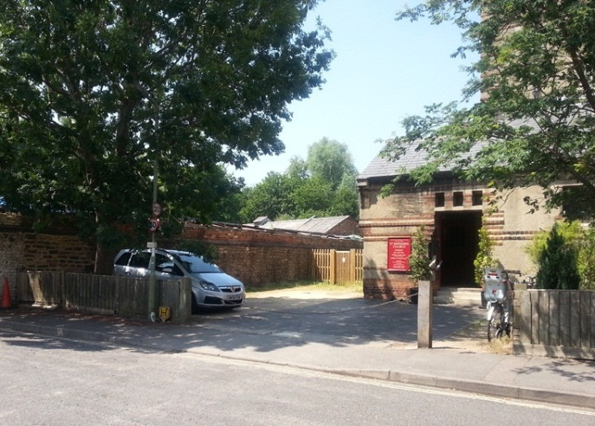
The preferred location is in front of the listed St Barnabas Church extending to the canal frontage. Consultation with the community also revealed a preference for this location. The boundary wall in front of the church should be removed (with listed building consent) in order to create an open back drop to the church. This will alter the relationship of the church to its surroundings but it is considered that this will be an enhancement and provide an essential focus for the public areas and community uses in the development, linking the church, the community centre and the canalside.
Wall at west end of the church to be removed
The clearance of untidy boatyard buildings and walls in front of the church would provide a much enhanced, framed setting when viewed from the canal towpath and new public space. Development should create a presence around the public square with active frontages. The longest southern edge of the square is an important frontage so in order to maximise the animation of the square the community centre should be positioned here. Further guidance in relation to design and heritage, in particularly the church, is in the next section.
Bridge
The City Council has long held the aspiration for a new bridge over the canal as an important element of the redevelopment of this site. Policy TR.5 (Oxford Local Plan 2001-2016) and the Policies Map indicate a new pedestrian and cycle route across the canal at this site. The justification for new routes is to improve the network along routes serving the city centre, cross-town routes and into sites of major travel generators. A new route across the canal at this site will enable pedestrians and cyclists a more direct route from Oxford Station to the major employment areas of the Radcliffe Observatory Quarter and Oxford University Press.
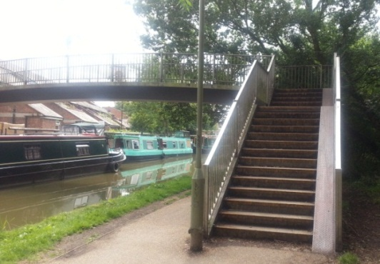
Policy SP7 states that “an improved crossing” should be provided. The inspector into the Sites and Housing Plan changed the requirement from “a new bridge” citing that there was an existing footbridge to the north of the site; that the required provision of a new footbridge relies on obtaining an agreement with a third party landowner on the far side of the canal; and that no assessment had been made as to whether a new bridge could be accommodated within the width of the canal bank.
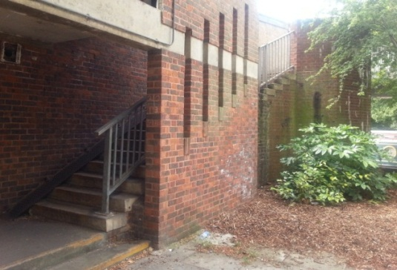
The existing footbridge to the north of the site is not easily accessible by cyclists so it does not create an adequate network for cyclists and pedestrians and certainly not for people with disabilities, mobility problems or people with pushchairs. There is no obvious solution as to how this bridge could be improved in a way that would allow access for everyone particularly as the east end of the bridge emerges through a building.
In addition, the bridge is leased to the City Council by the CaRT which expires in about 20 years. The Canal and Rivers Trust (CaRT) have indicated that they would be likely to take a more commercial view for future leases and may charge a significant fee. This will affect whether the City Council renew the lease and therefore the continued existence of that footbridge is not guaranteed.
The existing footbridge to the north of the site
The CaRT own the towpath land upon which a new bridge would need to be located. Despite previous unsuccessful negotiations with applicants, the CaRT are confident that they would be able to come to an agreement with a future applicant on the design of the bridge and that this would not create an obstacle to delivery.
The City Council consider that there is no option to delivering “an improved crossing” other than the provision of a new bridge for pedestrians, cyclists and people with disabilities. The bridge will be expected to be provided as part of the development and not as a financial contribution. The developer should grant permissive rights over the bridge in perpetuity.
Design
Bridges over canals are usually either arch bridges, swing bridges or lift bridges. Swing/lifting bridges can be designed “at grade” (level with the surrounding land) to allow the most easy access for cyclists and those with disabilities and are limited in their land take. A moving bridge also creates a point of interest for recreational users of the towpath. The drawback of these bridges are that they create an obstacle to boaters who need to stop, alight and raise the bridge before continuing on their journey, however, a raised bridge causes delays for cyclists and pedestrians for which the network improvement would be intended. To overcome this, a lifting bridge’s default position should be down.
An arch bridge allows constant access for boaters, pedestrians and cyclists. In order to be accessible by cyclists and wheelchair users means that slopes will be required which have a greater land take than swing and lift bridges. Depending on its precise location, this type of bridge has the potential to result in the loss of a considerable number of trees from within the Jericho Conservation Area. An arch bridge may also create a visual intrusion into views from the towpath to St Barnabas Church and also into views south down the canal’s tree lined green corridor. In considering the siting and method of construction of a bridge crossing the canal, special consideration will have to be given to conserving the contribution of the trees lining the canal towpath to the rural character of the canal corridor and their contribution to the amenity of views.
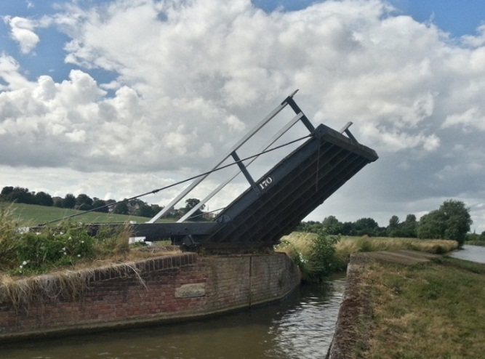
Both bridge types have positives and negatives and to some degree the design will depend on its location although a lift/swing bridge is likely to be preferable due to the reduced tree loss. As a new bridge linking the station with Jericho is a key element of the development of the site it is likely that some compromises regarding impact on the trees, views and boat users may be needed.
Opportunities for a fully DDA compliant bridge should be explored but some flexibility will exist to ensure that the bridge design is appropriate for its location.
An example of a lifting bridge on the Oxford Canal
Position
There are probably two potential positions for a bridge. The first is at the southern end of the site where pedestrians and cyclists crossing the canal would then have direct access along Great Clarendon Street to the major employers in Jericho. If the bridge was positioned here, then it is critical to have a decent width pathway retained along the canal frontage running north from the new bridge to create a clear and direct public access for pedestrians and cyclists to the new square (see Section 8.0).
The second possible position is more central on the site where the bridge would lead people directly into the new public space and increase the vibrancy of the space. Similarly, public access for pedestrians and cyclists will be expected along the canal frontage leading south from the square to enable people to quickly access the employment areas of Jericho without having to negotiate events taking place on the square.
It is also preferable for the bridge to be located south of the new winding hole. This ensures that boaters wanting to turn round before the end of the canal don’t have to negotiate the bridge twice to return north. The winding hole and bridge should not be too close to one another as the bridge may cause a visual obstruction to boaters affecting their safety.
As with the design options for the bridge, the position would also depend on the design of the bridge and to what degree it caused any visual intrusion and impact upon trees.
Other uses
Policy SP7 states that no other uses apart from those listed in the policy will be allowed. Such wording does allow for small scale ancillary uses on sites.
Class A uses
Class A uses include shops, financial and professional services and food and drink. A chandlery linked to the boatyard might be appropriate in this location. This site is not within the retail hierarchy as set out in Core Strategy Policy CS31 although, limited, small scale retail units may be appropriate provided that they are small scale in the context of the development site. Other Class A uses may complement the required uses by adding vitality to the new public space, encouraging people to come to the waterside and potentially increasing the viability of the development. However, because there are a number of uses which must be provided on this constrained site, Class A uses will not be appropriate if they are at the expense of the required uses.
It is uncertain whether Class A uses would be viable in this location so applicants will need to provide evidence to justify the viability of any proposals. If a retail unit was proposed potentially this could be combined with a chandlery. Proposals for retail will be assessed according to need, the sequential test, the requirement for good accessibility by walking, cycling and public transport, and their impact on existing centres. The planning application should provide detailed supporting information to assess the impact on existing nearby centres. Any retail units should not be of a scale or design where, under permitted development rights, they could be amalgamated to result in an inappropriately large retail unit for the site and local area.
Car parking, cycle parking and access
Residential
The site is well within the Transport Central Area and as such is expected to have low levels of car parking provision. Houses would be permitted a maximum of one space per house regardless of the size of the house although car free housing would also be an option. Development of flats should be car free. Wheelchair accessible or adaptable homes should have one space per dwellings whether a house or flat. Further details are in the Sites and Housing Plan Policy HP16 and Appendix 8.
Developments in the city centre and surrounding areas with little or no parking operate successfully in this way supported by the requirement that they exist within a Controlled Parking Zone and that residents would not be eligible for parking permits. This site is within a CPZ and residents of the new dwellings will not be permitted parking permits.
As a low car ownership development however it is important that good pedestrian routes and good levels of cycle parking provision are included as part of the development to take full advantage of the relatively central location of the site and the new pedestrian and cycle route created across the canal, especially towards the railway station and Said Business School, and beyond to the West End and to West Oxford. From here routes connect back not only to Jericho but also via Great Clarendon Street to major employment sites at the Oxford University Press and the Radcliffe Observatory Quarter.
Policy HP15 sets out the requirements for cycle parking on the site. It is recognised that there may be difficulties in accommodating the full cycle parking provision at convenient locations on a constrained site, and so some limited level of flexibility will be applied.
Community centre
The community centre is to serve the local area and given that the majority of users of the existing community centre walk, cycle or use public transport, the situation will not be significantly different for the new centre. For this reason the community centre would not need to provide general parking. The lack of car parking will not have a negative impact on the surrounding highway network due to the Controlled Parking Zone already in operation in the area. If possible a limited number of parking or drop off spaces could be provided for the use of disabled people attending the centre.
On site cycle parking requirements for community centres equates to 1 space per 20m² of seating/assembly floor space (Oxford Local Plan Appendix 4). As with residential cycle parking it is recognised to be a constrained site which may affect whether full provision would be appropriate.

Boatyard
Some limited car parking is required due to the nature of the work requiring the transportation of heavy equipment and machinery.
Access
The appeal Inspector into the 2007 application concluded that increases in vehicular movements were inevitable given the expectations for this site. The Inspector also concluded that vehicular access from Great Clarendon Street would be no more harmful than an entrance to the site from Cardigan Street.
Footway
A route for pedestrians, cyclists and plant machinery must be provided along the canal frontage to link Great Clarendon Street to the new public square. The suggested width is 3 metres to allow 1 metre for boat owners to access boats temporarily moored for DIY repairs plus two metres to provide an adequate space for pedestrians and cyclists. This space will also ensure that the Canal and River Trust can maintain the eastern canal wall with plant machinery through their retained 0.5 metre strip of land. Canal banks can sometime be accessed from the opposite towpath but on this section of canal access down the towpath by machinery is restricted due to the footbridges to the north and south.
Dog litter bins
As part of the production of the Sites and Housing Plan the City Council undertook a Habitats Regulation Assessment. This site was relevant to that assessment due to its proximity to the Oxford Meadows Special Area of Conservation (SAC) at Port Meadow. It concluded that development of this site might increase recreational pressure on the A. repens (creeping marshwort) at the SAC due to trampling and dog-fouling. Due to the potential increase in dog walkers that might live on the site and use the SAC, it was concluded that in order to mitigate these recreational impacts, dog and litter bins and an information board must be provided at the Walton Well Road entrance to Port Meadow as set out in Policy SP7.

Design principles
Urban design principles
Good urban design is essential to ensuring the quality of the public realm and the experience of users within it. People experience and understand a place by moving through its streets and other public spaces and the way they are defined by buildings and landscape that are important urban design principles. The fundamentals of the Urban Design Compendium and how they relate to this site are:
- Places for People: For places to be well-used and well-loved, they must be safe, comfortable, varied and attractive. The Jericho site should be distinctive and vibrant with active frontages to promote surveillance and maximises the amount of activity that takes place in the public realm.
- Enrich the Existing: New development on this site should enrich the qualities of the existing area. The Jericho site should encourage a distinctive response that arises from and complements its setting adjacent to the canal.
- Make Connections: Places need to be easy to get to and be integrated both physically and visually with their surroundings. There should be an ease of movement provided by legibility and permeability throughout the whole site. The priority on this site will be for people to get around by foot and bicycle with the car having a much lower priority.
- Work with the Landscape: The site should strike a balance between the natural and man-made environment and utilise these intrinsic resources. The tree-lined corridor between the canal and the Castle Mill stream are an important visual setting to the site.
- Mix Uses and Forms: Development on the site should weave together different building forms, uses, tenures and densities.
- Manage the Investment: For projects to be developable and well cared for they must be economically viable, well managed and maintained. The design should consider the development industry, ensure long term commitment from the community and the local authority and define appropriate delivery mechanisms.
- Design for Change: New development needs to be flexible enough to respond to future changes in use, lifestyle and demography. The development should design for energy and resource efficiency and create flexibility in the use of property and public spaces.
A critical aspect of the urban design will be the relationship between the community centre, the church, and the activity and visual interest of the boatyard and winding hole. Their position and design should provide an animation to the square and provide a focus for public interaction with the public square and canal frontage.
Preserving or enhancing the historic environment
Development will be expected to demonstrate the use of the following design principles in any proposal:
Respecting St Barnabas Church
- The maintenance of an open square between the church and the canal will be a required to protect the setting of the listed building;
- New elements added within the open space should not detract from the prominence of the church as a feature of these views. This will affect the choice of street furniture, including lighting and the choice of tree planting;
- In considering the scale and positioning of new buildings, consideration will have to be given to conserving the views of the church along Canal Street and from the canal. Some loss of these views is likely to be justified by the benefits of the scheme, but consideration should be given to preserving views of the roof slope and tower of the church from the canal, in addition to views across the open space;
- The design and materials of new buildings should provide contrast with the church, maintaining its architectural distinction within the area;
Character and appearance of the canalside
- New development will need to maintain an open frontage to the canal that preserves its character as an active, publicly accessible space, where the heritage of the waterway can be appreciated;
- New development that is not related to use of the canal or public uses should be set back from the canal and to preserve the character of views along the historic waterway;
- New development should provide uses that promote the active use of the waterway as a recreational resource, an area for residential moorings and a working waterway, as well as providing opportunities for positive interaction between the residential communities of Jericho and the canal;
- Buildings facing onto the canal should be designed using a scale, form, materials and detailing that make references to historic canalside structures. This does not mean that buildings should provide a pastiche of historic canalside buildings, however the influence of historic precedents on the architecture should be evident and understandable;
- New development along the canalside should include a variation of heights and divisions into larger units;
- The choice of street furniture within open spaces addressing the canal should be chosen to reflect the utilitarian historic environment of the canal. This should influence the choice of paving, seating and lighting in particular;
- New development should avoid the generation of significant overspill lighting affecting the dark night-time environment of the canal;
- Entry points to the former wharves area should be signposted by the use of ‘gate piers’ that reflect the historic division between residential streets and the industrial waterside although a ‘gated’ community will not be acceptable as this would provide an unacceptable division between the new and existing Jericho community;
- In considering the siting and method of construction of a bridge crossing the canal, special consideration will have to be given to conserving the contribution of the trees lining the canal towpath to the rural character of the canal corridor and their contribution to the amenity of views from the wharves.
Integrating with Jericho’s historic streets
- Where new development connects with existing residential streets:
  - The scale and placement of buildings should provide a continuation of the frontage line, scale and massing of existing buildings, including return frontages at street corners and buildings set at the rear of pavement, unless a setback is required to preserve views of St Barnabas Church or other important historic buildings (including the Radcliffe Observatory, seen in views framed by Cardigan Street).
  - Materials and forms used should reflect those of housing in the surrounding area, i.e. brick walls and slate roofs, with pitched roofs and a regular pattern of window and door openings. Door and window frames should be recessed into the brickwork, whilst roofs should include chimney stacks.
  - Buildings could make use of patterned brickwork to enliven main frontages. This may be limited to use of subtly contrasted coloured brick to emphasise window and door openings and create stringcourses. Brickwork should be laid in Flemish bond to reflect the detailing of surrounding historic housing and the choice of brick should reflect the materials of the historic cottages in the area.
  - Buildings should have roof profiles that reflect the pitch and ridge height of equivalent two or three storey historic buildings in the area.
- Dormer windows on forward facing roof slopes are not generally characteristic of the Jericho Conservation Area so exceptional design will be expected where proposed.
- New development should provide the maximum potential access from the existing residential streets to the canalside for pedestrians and cyclists and these routes should be given emphasis by the creation of framed views from Canal Street to the waterside.
Mix
To deliver a truly mixed development, a broadly equal mix of uses (boatyard, community centre, residential and public square) should be the starting point for design considerations. There will be flexibility depending upon the more precise requirements deemed necessary for the boatyard and community centre at the time of a planning application although no single use should excessively dominate the site. With a number of competing land uses expected on the site, in order to be achievable, it may not be possible to deliver the maximum amount of development aspired to by developers and the local community alike. There will need to be a level of compromise by each interested party.
The entire site should feel part of the Jericho community rather than some areas feeling entirely private. For this reason the active/public uses (community centre and boatyard) and the private dwellings should be spread across the site. This will ensure that the site integrates well into the local community.

Building heights and frontages
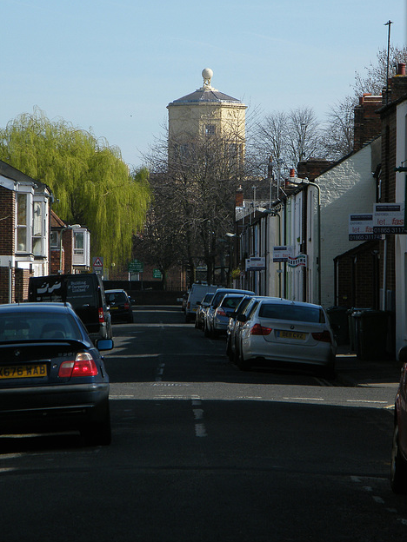
Policy SP7 sets a maximum building height of 3 storeys. For clarity, this does not automatically follow that 3 storeys will be acceptable across the entire site. The City Council will consider whether a proposal may have a negative impact upon neighbouring properties in particular whether a proposal caused overbearing or affected daylight and sunlight to nearby properties.
Any building provided on the southern edge of the new public square should consider the fortuitous view that exists from the towpath to the Radcliffe Observatory to the west. Clever design and roof pitch will be expected to minimise any adverse impact on this view. A building in this position will be very prominent on the square and from the towpath and will be expected to be a high quality landmark building. It will also be very visible from the view down Cardigan Street to the site.
The view along Cardigan Street to the Radcliffe Observatory (photo courtesy of Isisbridge)
New buildings positioned in Dawson Place that abut Canal Street will be expected to maintain the view south along Canal Street to St Barnabas Church. This will require building frontages along Canal Street to be set back slightly from the road.
Canal and River Trust Design Requirements
The Code of Practice for Works Affecting the Canal and River Trust (CaRT) gives guidance and details procedures for all those (The Third Party) whose work may or will affect the property of the CaRT. All works that affect the CaRT must comply with the Code. This includes but is not limited to construction works on the property of the CaRT, works undertaken on neighbouring property, works requiring access across the property of the CaRT and works that over-sail the property of the CaRT.
The CaRT offer a free pre-application advice service for applicants to ensure that their proposal will comply with their design requirements and not compromise the safety of boaters or users of the canal paths, nor compromise the waterway. The City Council will have expected applicants to have liaised with the CaRT prior to submitting a planning application.
The requirement for a footway along the east bank from Great Clarendon Street to the new public square is referred to in Section 6.0. One reason for this requirement is so that the CaRT can access the east canal wall for maintenance. Often the CaRT can access canal walls using machinery from the opposite bank but in this location the towpath opposite has restricted access for large machinery due to the listed Isis lock bridge to the south and the footbridge structure to the north. The CaRT have raised a concern that a number of canal banks have collapsed during recent periods of heavy rain and they would need to be satisfied that they could adequately access the canalside to ensure the canal remains safe.

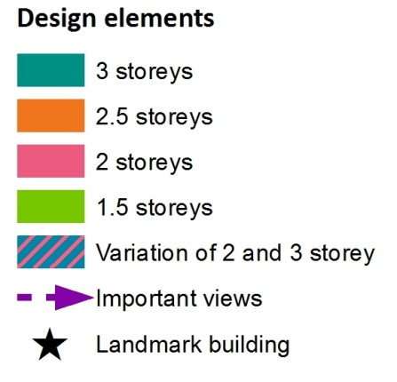
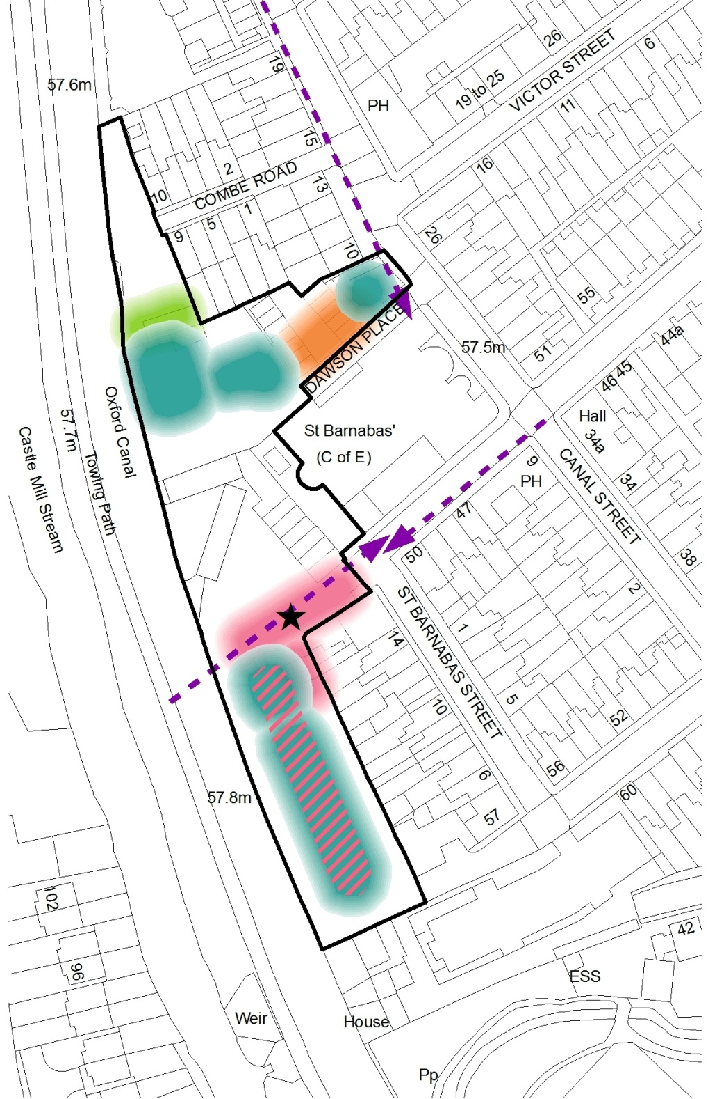

Framework plan
The position of the site on the canal, the unusual shape of the site, its position within the Jericho Conservation Area and the Listed church limit the options for siting new development. It will always remain quite a constrained site in this respect.
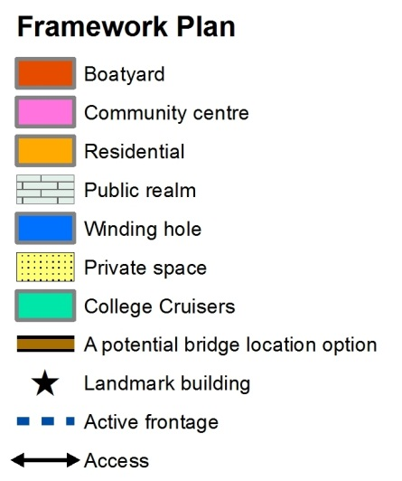
The Framework Plan below shows broadly how the City Council considers that the site should be developed in order to satisfy policy requirements. It balances all of the relevant issues discussed in the Brief to create a suitable layout and massing. In addition, an illustrative drawing of how this design might look has been provided. Any proposals will be judged on their merit against relevant policies and the SPD.
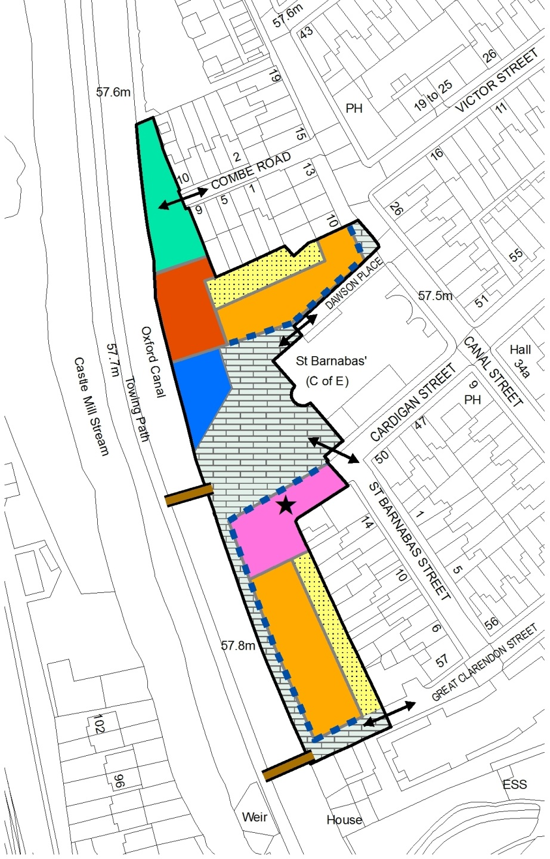
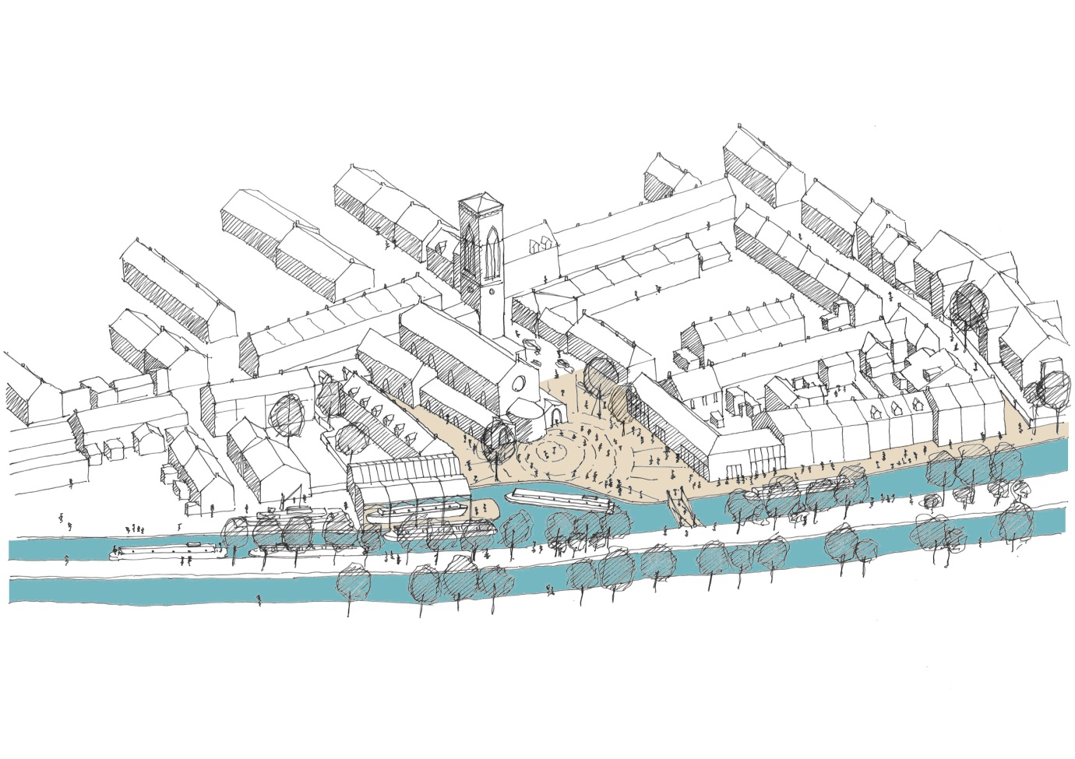
An indicative illustrative drawing of the Framework Plan and design principles

Delivery and implementation
Ownership
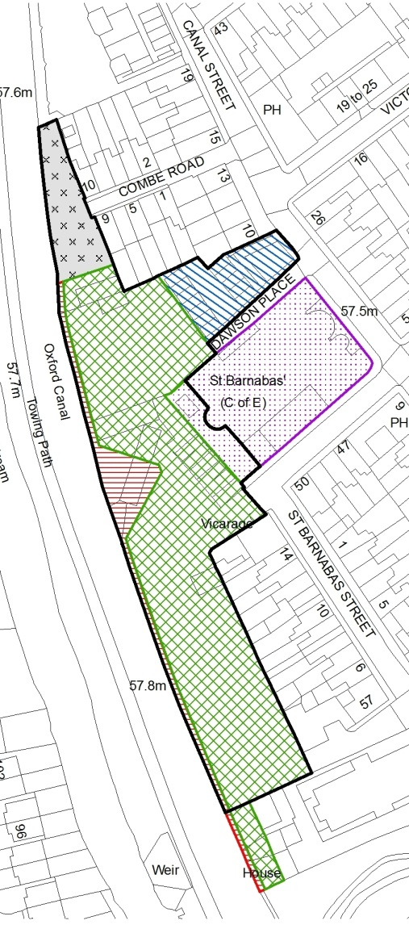
The majority of the site is under the control of administrators PricewaterhouseCoopers. The City Council are freeholders of the land at Dawson Place. The Canal and River Trust own land at the north of the site which is on a long lease to College Cruisers and is therefore unavailable for development. There are no proposals within this Brief for new development to be located upon the part of the site leased to College Cruisers. The Canal and River Trust also own a 0.5 metre strip on land along the length of the canal frontage for maintenance including a triangle of land intended for the new winding hole. The church own a piece of land in front of the west face which they would allow the public to use although would be unlikely to grant permissive rights.
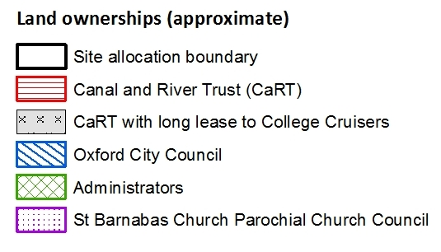
In 2005 Oxford City Council indicated their willingness to make available the land it owns in Dawson Place to facilitate provision of community facilities within the Jericho area. The City Council is willing, in principle, to allow its land to form part a comprehensive redevelopment of the Jericho Canalside site but only if, in the City Council’s opinion, the development meets the needs of the City and the local community, which include the principles set out in this brief.
Viability
The purpose of the Plan-led system is to direct development to certain locations and to influence the design of developments. Policies and planning guidance will have an effect on land values and the land value that will be need to be adjusted in order for the required land uses to be delivered.
On a site specific basis it is important that policies do not make the site unviable. The City Council are keen to see this site developed. For a scheme to be considered ‘viable’, it is generally expected that the residual value of a proposed scheme exceeds the Existing Use Value (EUV) or Alternative Use Value (AUV) by an appropriate margin.
The EUV is the value of the site in its current use. The site’s current land use is a boatyard which has a very low value. The site has no AUV because the land uses are determined by the Sites and Housing site allocation Policy SP7. The last two planning applications were not acceptable for a variety of reasons, and were determined under the background of different Development Plan policies. Therefore, the design and configurations of the previous planning applications cannot be considered as offering realistic alternative land values as each would have required a significant re-design in order to comply with policies at the time.
The site is currently in the hands of administrators who will be aiming to realise the property in order to make a distribution to creditors of Spring Residential Ltd. The developer who purchases the site will also have been expected to consider the financial implications of all policy requirements when making an offer for the site. It is accepted that they will seek to make an appropriate profit from development of the site. However, the City Council will not accept an applicant arguing a case for non-viability if the price paid for the land was inflated having not taken into account the full policy requirements and the site specific constraints.
The requirements of Sites and Housing Plan Policy SP7, as with any other site allocation or planning policy requirement, will impact upon the land value as explained above. However, the Brief does not place new onerous requirements which would affect the overall viability of the site when considered against the site’s Existing Use Value of a boatyard. In addition, the introduction in Oxford of the Community Infrastructure Levy in Oct 2013 will reduce the financial contributions expected from the development compared to the previous S106 mechanism because CIL is not expected from affordable housing.
All the requirements of the Brief are considered to be within the scope of Policy SP7. Any argument that the Brief has introduced an additional requirement for a new bridge compared to Policy SP7, which refers to ‘an improved crossing’, will be challenged. Firstly, there has never been any other realistic option to improve the crossing other than a new bridge. Secondly, up until the receipt of the Sites and Housing Plan Inspector’s Report in Jan 2013, a new bridge had always been a requirement of the draft site allocation Policy SP7 and the previous Policy DS.13 (Oxford Local Plan 2001-2016). Between Jan 2013 and the publication of the draft of this Brief (Sep 2013) the site was not been sold to a developer and therefore the requirement for a bridge in this Brief will have had a neutral effect on the land value compared to pre-Jan 2013.
The City Council consider that the site can deliver the requirements of the site and result in a residual value greater than the Existing Use Value as long as the developer pays an appropriate price for the land having considered all the financial implications of policy. Jericho Wharf Trust are confident that they can deliver a residual land value higher than the EUV without having to compromise on policy requirements.
Community Infrastructure Levy
The City Council expect to adopt its Community Infrastructure Levy (CIL) charging schedule in Oct 2013. CIL rates are calculated by square metre of development. Further information is available in the Council’s CIL Charging Schedule.

Water supply
Water supply capacity in this area is unlikely to be able to support the demand anticipated from development of this site. Policy SP7 says that Thames Water therefore require that applicants should fund investigations (which would be undertaken by Thames Water) to determine whether an upgrade to the water infrastructure is required. If the upgrade is required it could take up to three years lead in time for Thames Water to undertake any such works.

Further information
Oxford City Council publications
- Sites and Housing Plan (Feb 2013)
- Core Strategy (Mar 2011)
- Oxford Local Plan 2001-2016 (Nov 2005)
- Community Infrastructure Levy Charging Schedule (Oct 2013)
- Canalside Land, Jericho Development Guidelines (Oct 2001) - superseded
- Jericho Conservation Area Design Study (Oct 2010)
- Strategic Environmental Assessment Screening Report (June 2013)
- Interim Public Consultation Statement (Sep 2013)
- Affordable Housing and Planning Obligations SPD (Draft 2013). Affordable Housing SPD (2006) and Planning Obligations SPD (2007) - to be superseded upon adoption of the above
- Balance of Dwellings SPD (2008)
- Natural Resource Impact Analysis SPD (2006)
- Parking Standards, Transport Assessment and Travel Plans SPD (2007)
- Technical Advice Note 1: Accessible Homes (2013)
- Technical Advice Note 2: Energy Statement (forthcoming)
- Technical Advice Note 3: Waste Storage (forthcoming)
- Sites and Housing Plan Background Paper 18 Flood Risk: Sequential Test Update and Exception Test (Feb 2012)
- Strategic Housing Land Availability Assessment (Dec 2012)
- Habitats Regulation Assessment (Feb 2012)
Other documents
- Application number 03/01266/FUL and appeal decision APP/G3110/A/1152062 - Bellway Homes application for 46 dwellings, 37 car parking spaces, restaurant, chandlery, public square, winding hole and new footbridge
- Application number 07/01234/FUL and appeal decision APP/3110/A/08/2070447 - Spring Residential Ltd application for 54 flats, 16 car parking spaces, winding hole, public square, lifting bridge and boat repair berth
- Application number 07/01973/FUL and appeal decision APP/G3110/A/08/2070446 - Spring Residential Ltd application for landscaping works to St Barnabas Church
- Application number 09/01203/OUT – Jericho Community Association application for outline application for new community centre with entrance from Dawson Place
- Code of Practice for Works Affecting the Canal and River Trust (Apr 2013) Canal and River Trust
- The Town And Country Planning (Local Planning) (England) Regulations 2012
- National Planning Policy Framework (Mar 2012) Department for Communities and Local Government
- Level 2 Strategic Flood Risk Assessment (Feb 2012) Atkins
- Disability and Discrimination Act (DDA) 2004
- Urban Design Compendium (3rd Ed. 2013) Homes and Communities Agency
- Cities Outlook 2013 (Jan 2013) Centre for Cities

Appendices
Appendix 1: Planning history and analysis
This site has a lengthy and complex planning history. Decisions taken by both the City Council on planning applications and by independent planning inspectors on appeals are material considerations for future planning applications. The three most recent relevant applications are set out in more detail below.
June 2003: Bellway Homes application for planning permission for: 46 dwellings, 37 car parking spaces, restaurant, chandlery, public square, winding hole and new footbridge (03/01266/FUL)
Application refused in 2004 for the following reasons:
- Buildings inappropriate scale, design and siting with a detrimental effect on church and views and have an un-neighbourly impact upon adjacent properties;
- Overdevelopment and a physical and visual barrier disconnecting Jericho from the canal;
- Footbridge and ramps would be over dominant in views, and relate poorly to Isis Bridge and result in an unacceptable loss of trees;
- No provision for community facilities;
- Inadequate affordable housing provision;
- No detailed and adequate ground remediation and mitigation strategy;
- Increase in flood risk;
- Loss of essential canal and waterside facilities.
Appeal dismissed in 2005 for the following reasons:
- Inadequate space provided for the community centre;
- No provision for replacement boat facilities in another equally accessible and convenient location (absence of lifting facilities not a reason for refusal in itself)
Other key points made by the inspector:
- The footprint/site for the community centre should be considerably larger than 260m²
- Facilities for boats to be lifted from the water and inspected, maintained and repaired are essential to the boating community
- The site is not suitable for a more intensive and commercial boat repair business
- Buildings should create a presence around the square and church to create a sense of place. The hemming-in of the church by development is acceptable and outweighs loss of views from the towpath
- The contemporary approach and a slightly larger scale of development as proposed would not be harmful

City Council commentary
The appeal decision gives an indication on what the appropriate size of a community centre should be. It also is clear that if boating facilities are provided in an equally accessible and suitable location(s) then that may be an acceptable approach. The Inspector concluded that the site wouldn’t be suitable for an intensive commercial boatyard, however, this was in the absence of understanding how noise could be mitigated. If suitable noise mitigation was included in a proposal, this might allow for a more intense use of the boatyard. The Inspector was clear in the report on how the setting of the church could be improved and the balance between loss of views and creating a presence in the square. All of these aspects emerging from the Inspector’s Report have been incorporated into the Development Brief.
June 2007: Spring Residential Ltd application for planning permission for: 54 flats, 16 car parking spaces, winding hole, public square, lifting bridge and boat repair berth (07/01234/FUL) and landscaping works to St Barnabas Church involving insertion of gates, railings and boundary wall (07/01973/FUL)
Main application refused in 2007 for the following reasons:
- Inadequate provision of affordable housing
- Performs poorly in relation to resource and energy efficiencies
- Inadequate justification for the level of contribution for the County Council
- Absence of legal agreement securing parcel of land for community centre
- Loss of essential canal and waterside facilities without adequate replacement in an equally accessible and convenient location
- By reason of excess height, bulk and scale and uncharacteristic materials fails to respect the established predominantly 2 and 3 storey domestic scale of Jericho
- Fails on urban design principles of active frontages
- Relates poorly to the church
- Unacceptable increase in flooding
Church landscaping application refused in 2007 for the following reasons:
- Premature in absence of a satisfactory scheme on the adjacent site
- Unsatisfactory materials
Appeal dismissed in 2008 for the following reasons:
- The re-provision of support services for boat users in an equally accessible and suitable location will not be fulfilled
- The water related land use element will be relegated to a small discreet part of the site which is unfortunate in this area where canal and boating are important elements of its character
- The preponderance of residential around the edges of the public square would render it sterile and inactive, lacking a sense of distinctive place with little connection to the character or history of Jericho
- The design fails to take the opportunities for improving the character and quality of this area
Other key points made by the inspector:
- The quantum of built development on the site would make effective use of urban land but without a sense of over-development. The alignment of buildings and scale would be an appropriate response to the waterside context
- The building’s monotonous appearance would add to the sense of an inanimate environment
- The need for the winding hole is questionable
- Flood compensation measures are achievable
- Increased parking on site would be wasteful of a valuable brownfield site and a car free development in this location is possible
- Noise generated by boat repair activities could be controlled by condition restricting hours of operation
- The onus must fall on the developer to take on board the consequences of the affordable housing and other policy requirements at the time of purchasing the site
- The costs are specific to this site and reflect its unique circumstances
City Council commentary
The Inspector is critical of the peripheral position of community uses on the site and does not support the square being surrounded only by residential uses. The Inspector is also critical of the monotony of the development suggesting that a more varied design would be appropriate. The Inspector confirms the City Council view that this would be a suitable location for car free development. The inspector suggests that the boatyard repair operating hours could be restricted. These aspects emerging from the Inspector’s Report have been incorporated into the Development Brief.
The appeal decision is clear that the quantum and scale of the proposal and alignment was appropriate, however, the City Council would maintain that the scale was excessive. The need for a winding hole is questioned. The Canals and Rivers Trust, local boaters and the City Council consider that it is important to the development. The Inspector did not seem to take account of the fact that boats cannot go through Isis Lock to turn around when the river is in flood meaning that large boats have nowhere to turn. As such Policy SP7 limits development to 3 storeys.
Finally, in relation to affordable housing provision and viability, the Inspector comes to a somewhat contradictory view. In the first instance she states that the onus is on the developer to consider the consequences of affordable housing and other policy requirements at the time of purchasing the site. The Inspector then states that the specific costs associated with the site are justification for accepting a lower provision of affordable housing. The City Council disagree with this reasoning as the specific costs associated with the site were all clearly included as policy requirements which should have been taken into consideration when purchasing the site.
June 2010: Outline application (seeking access and layout) for new community centre with entrance from Dawson Place (09/01203/OUT)
Application approved in 2010 for the following reasons (summarised):
- The proposal, whilst not complying with all Oxford Local Plan 2001-2016 policies, is considered acceptable and provides a much needed community centre. The loss of trees has to be set against the improved visual amenity of the locality by replacing an untidy garage court with a new building, and by the other wider benefits of providing a new community centre for Jericho
- Many of the public comments received are supportive
- Any material harm that the development may give rise to can be offset by conditions
City Council commentary
The decision has set a precedent for the loss of the trees in Dawson Place. Any new proposal will be considered on its merits although a similar conclusion is likely to be drawn in relation to balancing the loss of trees against the improved visual amenity of the site and the community benefits.

Appendix 2: Other relevant non-City Council consultations
Haworth Tompkins Ltd Masterplan Consultation
Haworth Tompkins, architects, developed a Masterplan for a community-led proposal for the site in liaison with Jericho Living Heritage Trust, Jericho Community Association, Jericho Community Boat Yard Ltd, Canal and River Trust and St. Barnabas Church. They undertook three stages of consultation with the final stage being a two day open event for the public where over 150 people attended. A number of the questions related to very detailed aspects of the proposed Masterplan which are less relevant to this Brief. The elements which relate to the location of the uses and design are relevant and responses are summarised below:
- About 66% favoured the community centre being located directly onto the square;
- About 80% did not think there should be shops on both sides of the square;
- Favoured materials were brick, glass and wood (including reclaimed wood) and environmentally sustainable materials;
- 70% did not want to see the Dawson Place green built on;
- Of those who stated a preference, about 66% favoured a bridge leading directly into the square compared to at the southern end;
- A majority favoured a moving bridge but a significant proportion recognised the problems this would cause boaters. A number of people suggested restricting boat usage during the rush hour to give pedestrians and cyclists priority;
- Of those who answered, the majority said that they would buy from a chandlery on the site.
Jericho Wharf Trust Residential Boaters survey
During the summer of 2012 Jericho Wharf Trust distributed questionnaires to as many residential boat owners as possible within Oxford, seeking to build a profile of these boat dwellers and their needs and 56% responded. Much information was gathered. Of particular relevance to this Brief are the following summarised issues and responses:
- An earlier census (autumn 2011) identified more than 400 boats in the wider Oxford area, of which 109 were residential boats moored on the canal or river within the Oxford City boundaries;
- Responding to whether the loss of the boatyard had an impact: None 26%; A Little 26%; Quite a Lot 19%; A Great Deal 29%;
- 75% of respondents agreed that “the previous Jericho boatyard also provided a place that helped the boating community’s sense of well-being.”
- 62% or respondents described deterioration in boat maintenance and/or safety;
- 39% described loss of community and/or alienation;
- The majority considered it ‘very important’ that the any new boatyard was located in Oxford and had out of water DIY facilities. It was considered slightly less important to have pump-out and toilet facilities.

Jericho Community Association Community Survey 2013
This survey aimed to identify people’s concerns and priorities and to show which projects would be most appropriate. Of particular relevance to this Brief are the following summarised issues and responses:
- Respondents were asked for their views about the proposed facilities for the new Community Centre at Canalside and to add any other facilities they would like. A mix of rooms sizes was sought. Nearly 50% of respondents would use music and arts facilities either regularly or occasionally, 46% would use a history house; a total of 42% of respondents expressed an interest in using a gym; 39% would use a bike workshop; 31% DIY; 30% would use an IT facility and 21% would use a laundrette;
- The results suggest that popular choices for the public square include: a market/food/street fair; a café/eating out/food area; and a space for parties, music, dance and drama (street theatre);
- The survey stated that a proposed pedestrian/cycle bridge would provide a direct link from Jericho to the station area, and asked respondents: How often do you think you personally would use it? A total of 89% of respondents stated that they would use it, with 38% using it at least once a week; 32% using it less than once a week and 19% stating they would use it every day.

